**MSBC 5490**

**BUAN Experiential Project**

**Rudi’s Bakery**

**Model Performance Report**

**Submitted by Group 4:**

| **Name** | **Email Address** |
| --- | --- |
| Rafael Cintron | rafael.cintron@colorado.edu |
| Jinal Mehta | jinal.mehta@colorado.edu |
| Pranathi Manthri | pranathi.manthri@colorado.edu |
| Murali Prateek Manthri | murali.manthri@colorado.edu |
| Supria Deka | supria.deka@colorado.edu |

**Index**

| **Topic** | **Page Number** |
| --- | --- |
| Executive Summary | 2 |
| Key Insights and Findings | 2 |
| Business Impact & Strategies Based on the Models Executed | 6 |
| Data Preprocessing And Model building and Evaluation | 8 |
| Adapting this information to an Interactive Dashboard | 16 |
| Generative AI Appendix | 21 |

**Executive Summary:**

Rudi’s Bakery, a prominent manufacturer of organic and gluten-free bread, operates under a Direct Store Delivery (DSD) model and sought data-driven solutions to enhance sales forecasting, detect anomalies, and optimize inventory management.

We performed an in-depth analysis of historical sales data, utilizing forecasting methods and anomaly detection to improve strategic decision-making.

To address these challenges, we executed data preprocessing, feature engineering, and predictive modeling in Python using Google Colab.

Our main task focuses on the following:

* Deploying Moving Average Forecasting & ETS models to project sales trends.
* Applying anomaly detection techniques to identify stores with abnormal product return rates.
* Designing an interactive Tableau dashboard to provide actionable sales insights.

**Key Insights & Findings:**

1. **Top 10 Most Profitable Stores**: A key finding in our analysis is the evaluation of total net sales across store locations to identify top-performing stores, assess revenue distribution, and explore factors influencing sales variations.

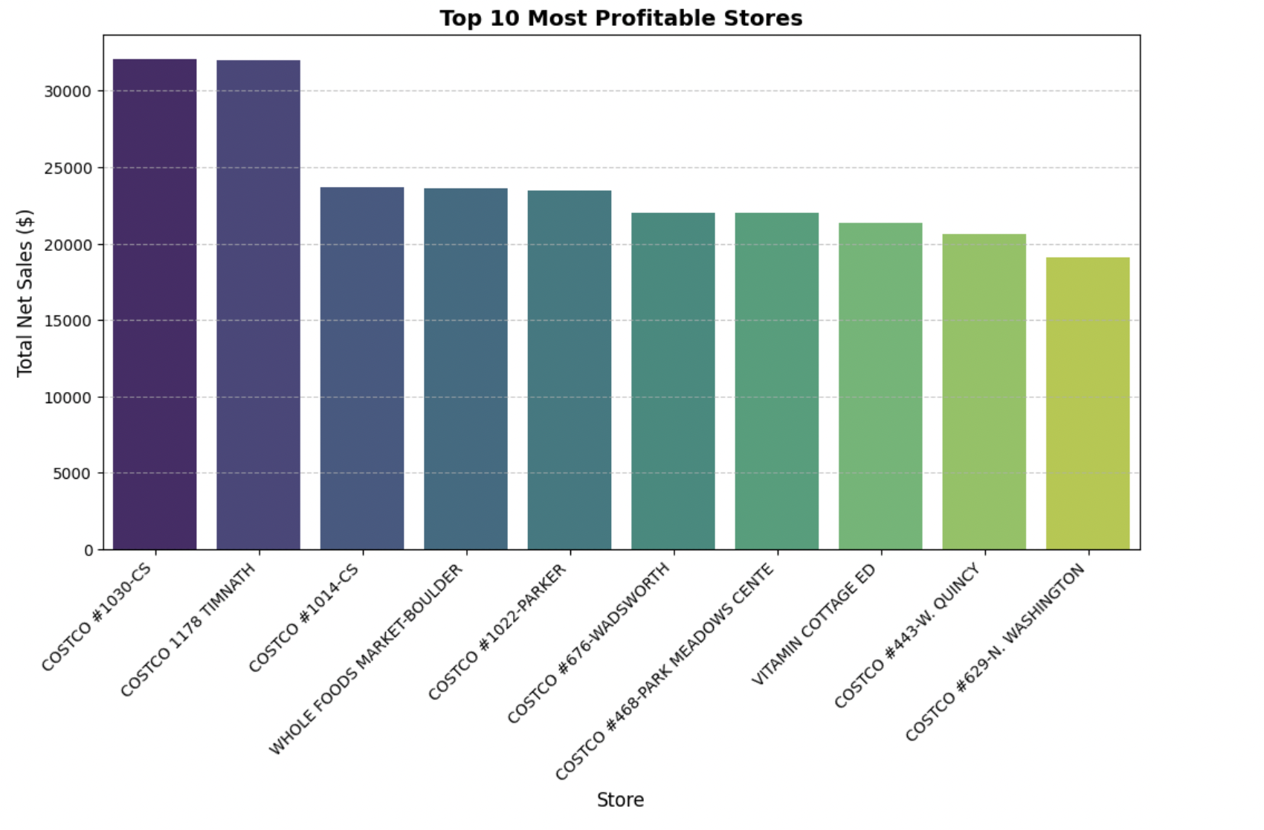

Fig. 1:Top 10 Most Profitable Stores

* From the figure, we can infer that, *Costco stores* dominate sales performance, with *COSTCO #1030-CS ($32,087.50)* and *COSTCO 1178 TIMNATH ($32,012.50)* leading in revenue.
* Other strong performers include *COSTCO #1014-CS*, *Whole Foods Market-Boulder*, and *COSTCO #1022-PARKER*, all exceeding $23,000 in net sales.
* While *Whole Foods* made it into the top rankings, *Costco* locations consistently outperformed competitors.
* The lowest sales were observed at *COSTCO #629-N. WASHINGTON ($19,125.00)*. The revenue gap between top and lower-performing stores suggests potential for sales optimization and further analysis into regional demand, store traffic, and pricing strategies.
* *Whole Foods Market* and *Vitamin Cottage ED* perform well but do not surpass *Costco’s* best-performing stores.

1. **Top 10 Products with Highest Returns:** We analyzed product return patterns by evaluating Total Returns, Average Returns, and Transactions to identify high-return SKUs, assess their impact on sales, and explore ways to reduce returns and improve customer satisfaction.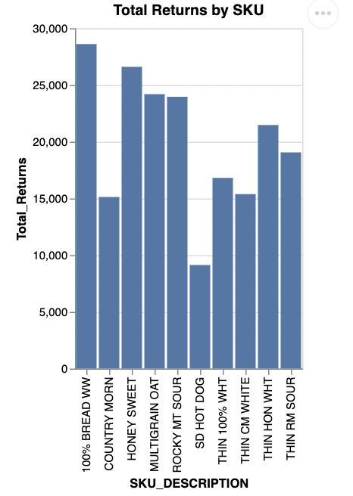

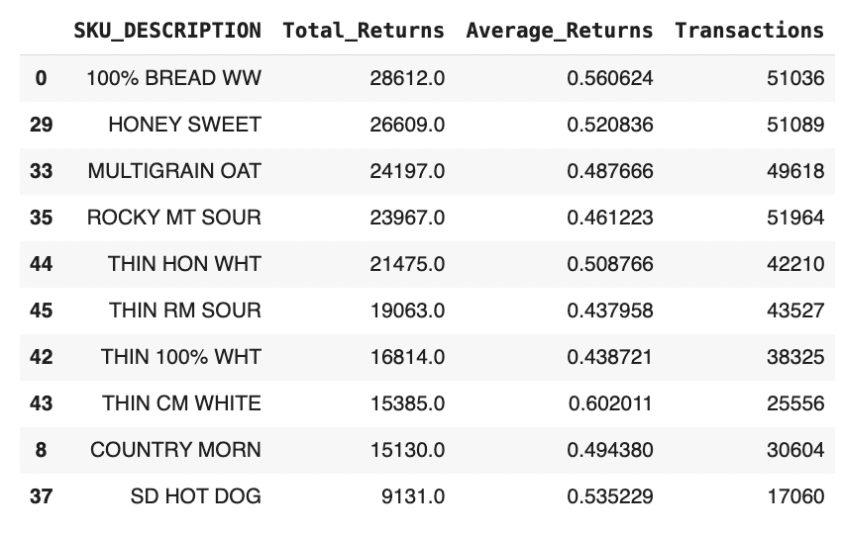

Fig. 2: Top 10 Products with Highest Returns

### 

### *MULTIGRAIN OAT (4,133)* and *HONEY SWEET (3,713)* have the highest total returns, followed by *THIN HON WHT (3,355)* and *ROCKY MT SOUR (2,956).*

### The highest Average Return Rate is observed for *GF SUPER SEED (0.512)*, suggesting over 51% of transactions resulted in returns, while *THIN RM SOUR (0.220)* has the lowest return rate.

### Despite high return volumes, products like *HONEY SWEET* and *100% BREAD WW* also have high transaction counts, indicating strong sales despite returns.

### These insights suggest a need for further investigation into quality issues, customer preferences, or product expectations to reduce return rates while maintaining high sales.

1. **Most Profitable Product:** This analysis identifies the most profitable products based on Total Net Profit (Net Sales after Returns). By evaluating the profitability of each SKU, we can determine which products contribute the most to overall revenue and assess potential areas for optimizing sales strategies and inventory management.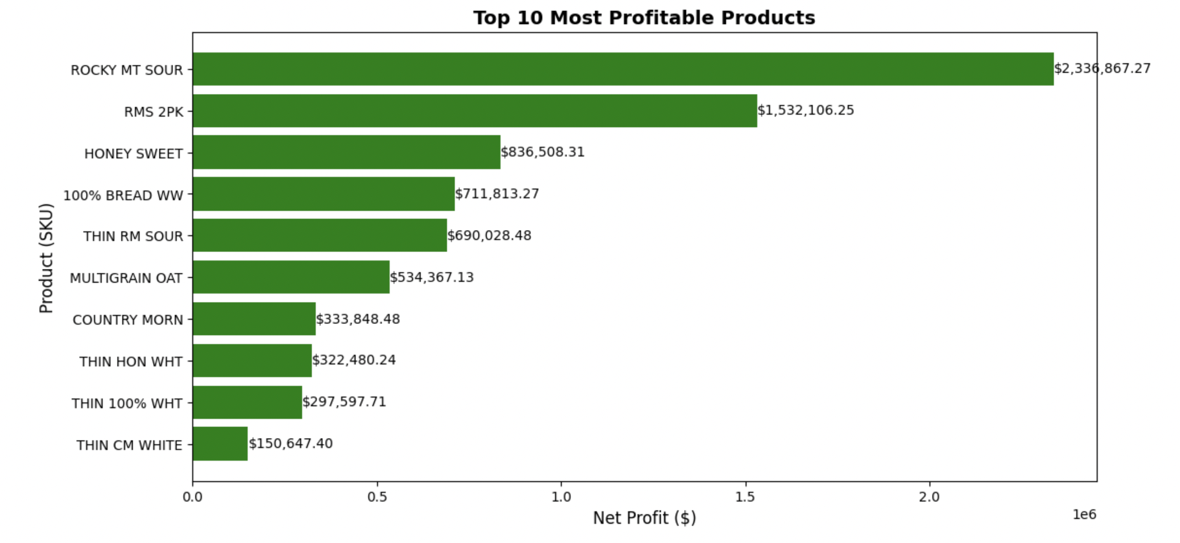

Fig. 3: Top 10 Most Profitable Products

* *ROCKY MT SOUR ($2,336,867.27)* is the most profitable product, followed by *RMS 2PK ($1,532,106.25)* and *HONEY SWEET ($836,508.31)*. These top three products significantly outperform the rest in terms of net profit.
* Other high-performing SKUs include 100% *BREAD WW ($711,813.27)* and *THIN RM SOUR ($690,028.48)*, indicating strong sales after accounting for returns.
* Lower-ranked but still profitable items such as *THIN HON WHT ($322,480.24)* and *THIN 100% WHT ($297,597.71)* suggest opportunities for further sales growth.
* The dominance of specific product types highlights potential consumer preferences, guiding future marketing and inventory decisions.

1. **Retailer Return Analysis Across Routes:** Here, we tried to understand the return unit trends across various retailers and routes, identifying key contributors to high return volumes and potential factors influencing these patterns. By analyzing return data, we aim to understand retailer-specific and location-based return behaviors, assess inventory efficiency, and explore opportunities to optimize return policies and logistics.

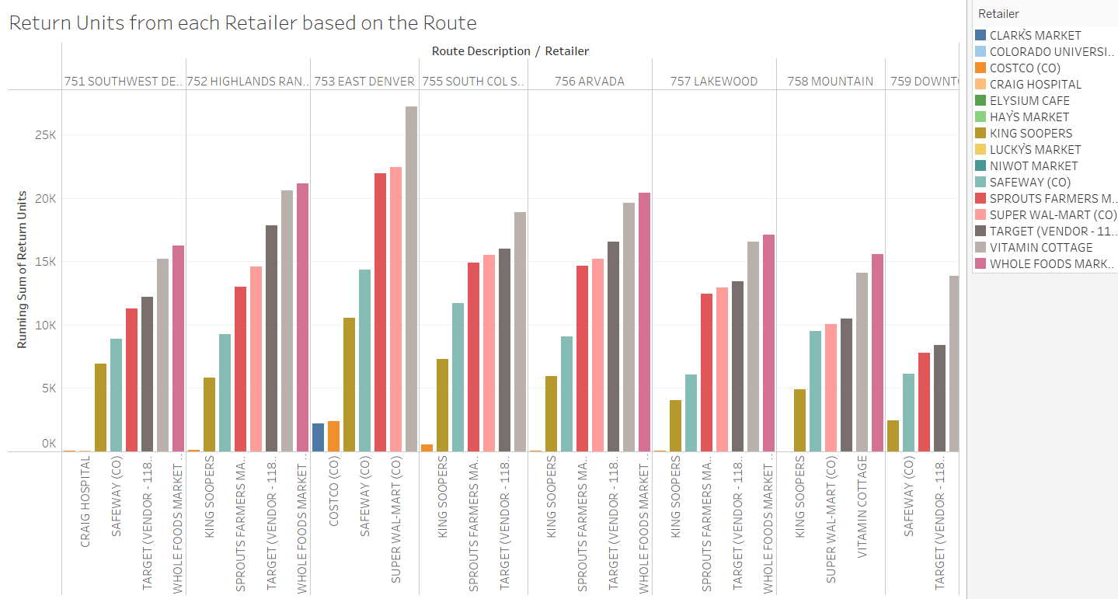

Fig. 4: Return Units from each Retailer based on Route No.

* *Target, Whole Foods Market, and Super Wal-Mart (CO)* consistently have the highest return volumes, likely due to higher product turnover, customer return behaviors, or flexible return policies.
* Routes like *753 East Denver and 755 South Col S*... experience particularly high returns, suggesting regional influences on return patterns.
* Moderate return volumes are observed for *Sprouts Farmers Market, Safeway (CO), King Soopers, and Costco (CO),* indicating better return management or different customer behavior.
* In contrast, *Clark’s Market, Craig Hospital, Elysium Café, and Niwot Market* report minimal returns, likely due to smaller customer bases, specialized products, or stricter policies.
* Geographic variations highlight the need for route-specific return management, while large retailers may benefit from reviewing return policies, inventory optimization, and logistics efficiency to minimize operational costs and improve customer satisfaction.

1. **Profitability and Return Rate by Route No.:** This analysis examines the relationship between *Total Net Sales and Return Rates across different routes* to identify profitability trends and potential inefficiencies. By evaluating the net sales performance and return rates for each route, we can determine which routes contribute the most to overall revenue and where high return rates may indicate operational challenges or product issues.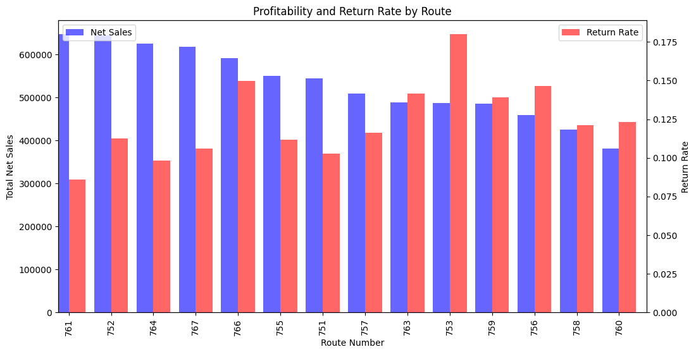

Fig. 5: Profitability and Return Rate by Route Number

* *Routes 761, 752, and 764* generate the highest Total Net Sales with moderate return rates, indicating strong revenue but potential for further optimization.
* *Route 753 and 759* have high return rates despite strong sales, suggesting possible product quality issues or lenient return policies.
* *Routes 763 and 756* experience moderate sales but disproportionately high returns, pointing to operational inefficiencies or customer dissatisfaction.
* Conversely, *routes 760 and 758* have lower sales but minimal returns, indicating stable yet limited demand, which could benefit from promotional efforts to boost profitability.

### **Business Impact & Strategies Based on the Models Executed:**

The models executed in the analysis (mentioned below) offer valuable insights into sales trends, store profitability, product returns, and forecasting accuracy. Below are the key business impacts and strategies based on the findings:

#### **1. Sales Performance & Profitability: The top-performing stores, particularly Costco locations**, drive the majority of sales, while lower-performing stores may need sales optimization strategies. Hence, focusing on high-performing stores for inventory expansion while investigating factors limiting growth in underperforming stores, such as pricing, foot traffic, or regional demand.

#### **2. High-Return Products & Customer Satisfaction:** Certain SKUs like *Multigrain Oat, Honey Sweet*, and *Thin Hon Wht* have significantly high return rates, leading to potential revenue loss. To address this concern, conducting a root cause analysis on product quality issues, customer expectations, and return policies will be helpful. Furthermore, reducing return rates by adjusting product packaging, improving shelf life, or offering targeted customer education.

#### **3.** **Retailer-Specific Return Patterns:** Retailers such as *Target, Whole Foods Market,* and *Walmart* exhibit high product returns, indicating potential inefficiencies in inventory turnover or customer return policies. We can infer that indulging with these retailers to analyze return reasons and adjust stock levels accordingly. Offer incentives for customers to exchange products rather than return them.

#### **4.** **Route-Based Profitability & Return Rates:**Certain store routes generate high net sales with moderate return rates, while others experience disproportionately high returns despite strong sales. To mitigate this, optimizing logistics and distribution planning for high-return routes can help reduce inefficiencies and improve product handling. Identifying operational bottlenecks and addressing issues such as inventory mismanagement or transportation-related damages will further enhance efficiency. Additionally, shifting high-return products to more controlled store environments, such as locations with better inventory tracking or stricter quality control measures, could minimize returns and improve overall profitability.

#### **5.** **Forecasting Accuracy & Demand Planning:** Sales forecasting using *Random Forest and Prophet Models* identified seasonal demand fluctuations, but struggled to capture extreme spikes. To address this concern, we can enhance predictive accuracy by integrating external factors such as holidays, promotions, competitor pricing, and economic conditions to adjust inventory levels proactively.

#### **6. Cluster Analysis on Net Sales by ZIP Code:** Store performance varies significantly across ZIP codes, with some locations thriving while others struggle. Using clustering insights to optimize store locations, reallocate inventory, and personalize marketing strategies based on regional demand.

### 

### 

### **Rationale for the Chosen Approach**

The selected approach integrates predictive modeling, clustering, and anomaly detection to enhance sales forecasting, optimize inventory management, and identify key areas for operational improvements. Moving Average Forecasting and Exponential Smoothing were used to analyze sales trends, while machine learning models like Random Forest and XGBoost provided accurate sales predictions. Clustering techniques grouped stores based on ZIP codes and sales performance, enabling targeted strategic decisions. Anomaly detection identified outliers in return rates and sales patterns, ensuring better quality control and policy adjustments. This combination of techniques offers a data-driven approach to improving profitability, reducing losses, and enhancing decision-making efficiency across retail locations.

**Data Preprocessing And Model Building and Evaluation:**

1. **Anomaly Detection Analysis and Insights:** When checking for the outliers as a part of EDA for the numerical columns, extreme values were identified in columns like *Gross Dollars* (maximum $1,350) and *Return Dollars* (maximum $443.75), which may skew the averages.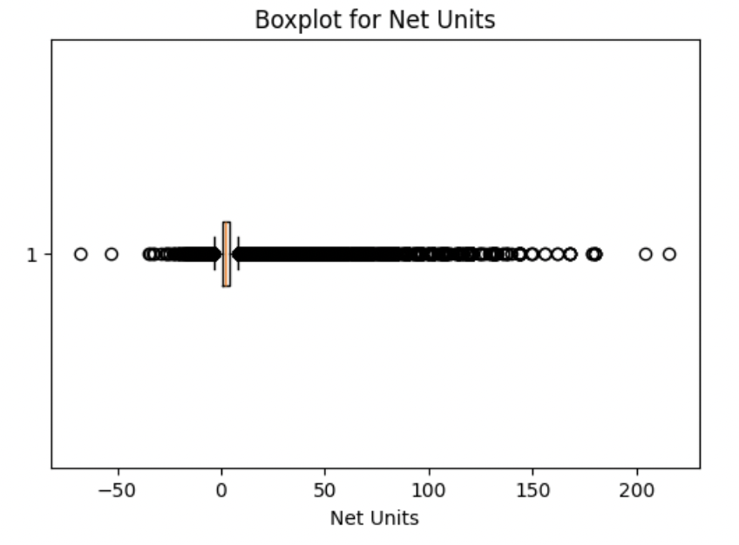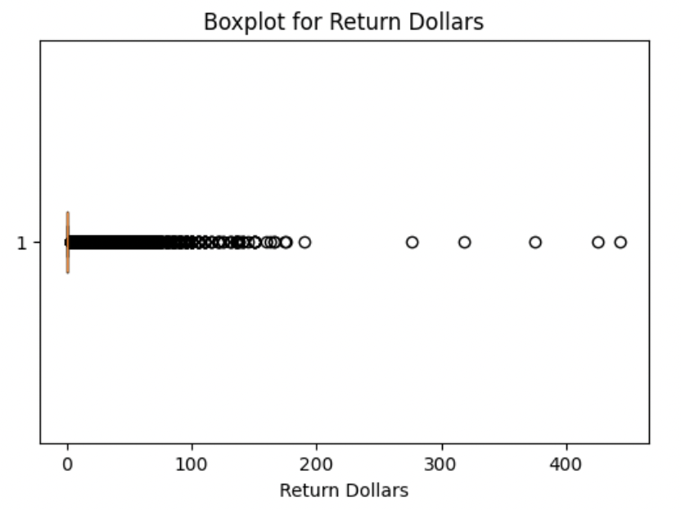

Fig. 6: Outlier/Anomaly detection for numerical columns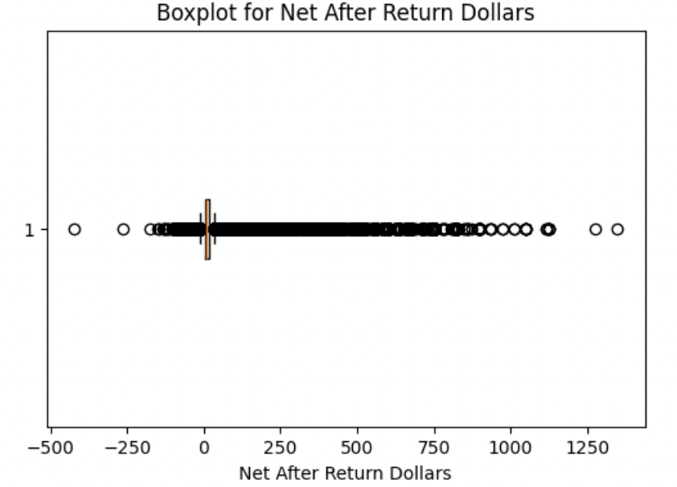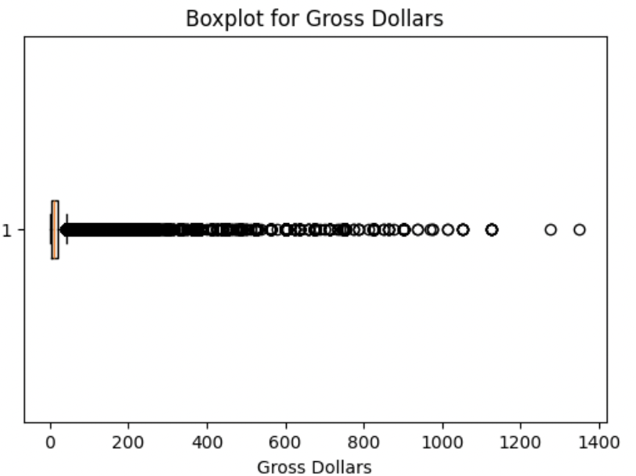

Fig. 7: Outlier/Anomaly detection for numerical columns

Anomaly detection helps identify unusual patterns in sales data that could indicate errors, fraud, or exceptional cases. The Interquartile Range (IQR) method was applied to detect outliers in gross sales, return dollars, and net units. The boxplots highlight extreme values in gross sales, return sales, net unit and net after return dollar showing many points above the upper whisker, indicating potential outliers.

These visualizes anomalies, with small circles representing unusual sales values that deviate significantly from the norm. These anomalies may result from data entry errors, exceptional sales spikes, fraud, or unusual returns.

Handling these outliers is critical and hence replacing them with median values ensures better model performance.

1. **Data Preprocessing/Cleaning :**

The dataset was thoroughly cleaned by appropriately handling missing values and removing duplicate rows and columns to ensure data integrity and accuracy. As a part of feature engineering, we have added a new feature/column named *STORE_ ZIP*, that is added to enhance location-based insights.

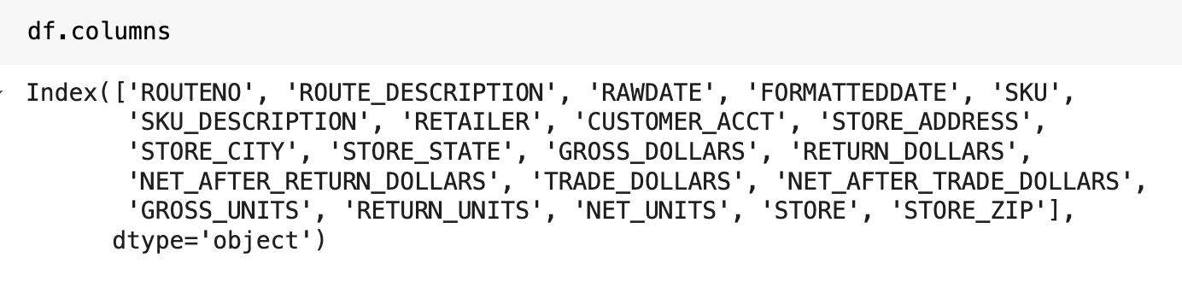

Fig. 8: Column names displayed after merging the zipcodes

**Models that were executed and analyzed is listed as below:**

1. Linear Regression
2. Random Forest
3. Time series Analysis : *Prophet*
4. Exponential smoothing
5. Decision Tree
6. Clustering
7. Interactive Dashboard

**1. Linear Regression Vs Random Forest :** We executed both these models to do analysis and to compare the performance of two predictive models, based on their Mean Squared Error (MSE) and R-squared (R²) scores. Additionally, we tried to extract the importance of different features contributing to the predictions.

We initially split the dataset into a training set (468,396 records) and a testing set (117,099 records). To mitigate potential overfitting, we trained a Random Forest Regressor with 100 estimators and a fixed random state for validation.

**Performance Metrics**:

| Model | MSE | R Squared |
| --- | --- | --- |
| Linear Regression | 0.78 | 0.98 |
| Random Forest | 0.05 | 1.00 |

Table 1: Comparison Analysis based on MSE and R Squared.

The Random Forest model demonstrates significantly higher precision in predictions, as indicated by its much lower Mean Squared Error (MSE) compared to the Linear Regression model. Additionally, it achieves an R² score of 1.00, suggesting an almost perfect fit, whereas the Linear Regression model attains an R² of 0.98, which remains strong but is slightly lower in comparison.

### **Feature Importance Comparison**

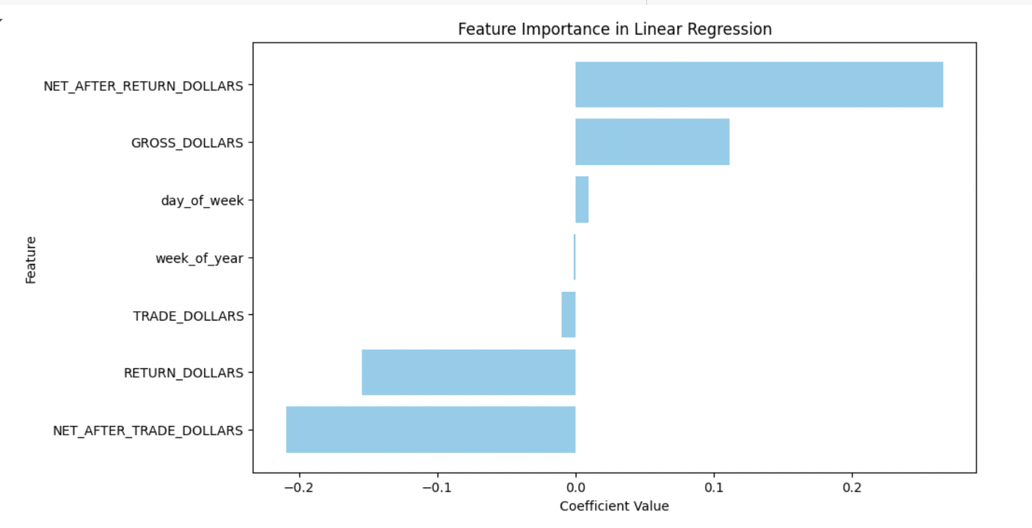

Fig. 9: Important Feature Extraction (Linear Regression)

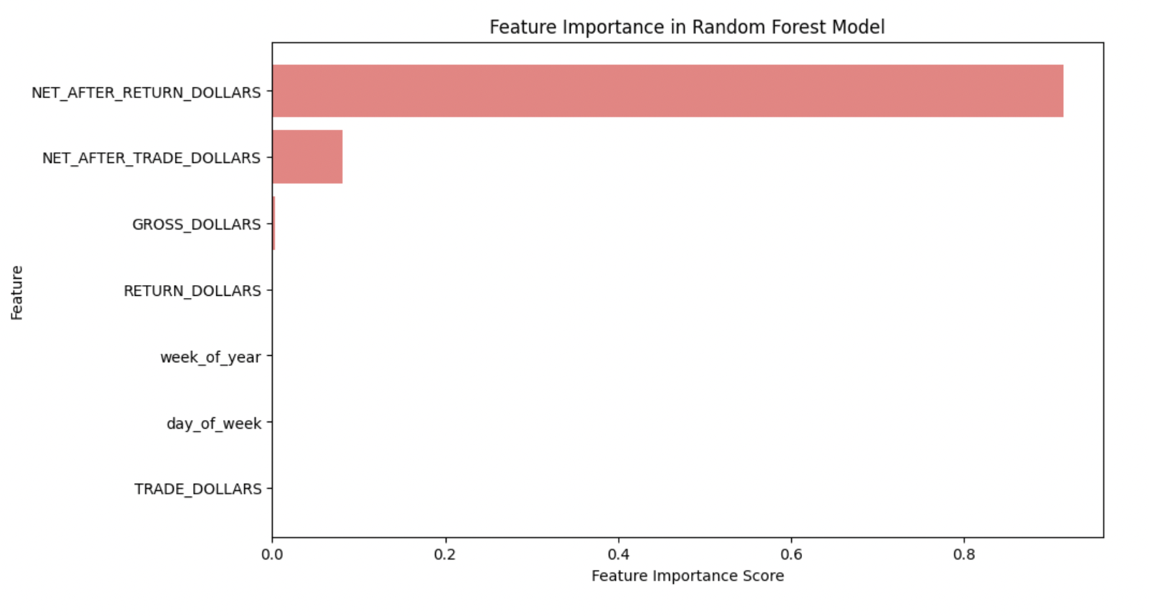

Fig. 10: Important Feature Extraction (Random Forest)

The key predictors are *NET_AFTER_RETURN_DOLLARS*, *NET_AFTER_TRADE_DOLLARS*, and *GROSS_DOLLARS*, while temporal factors have minimal impact.

**2.** **Forecasting Sales:** This analysis evaluates the *forecasted vs. actual sales for TARGET (VENDOR - 1184860)_2060 and KING SOOPERS_4120* using a *Random Forest model*. The goal is to assess how well the forecasted values align with actual sales data and identify trends or discrepancies in the prediction model.

1. **Retailer: Target**

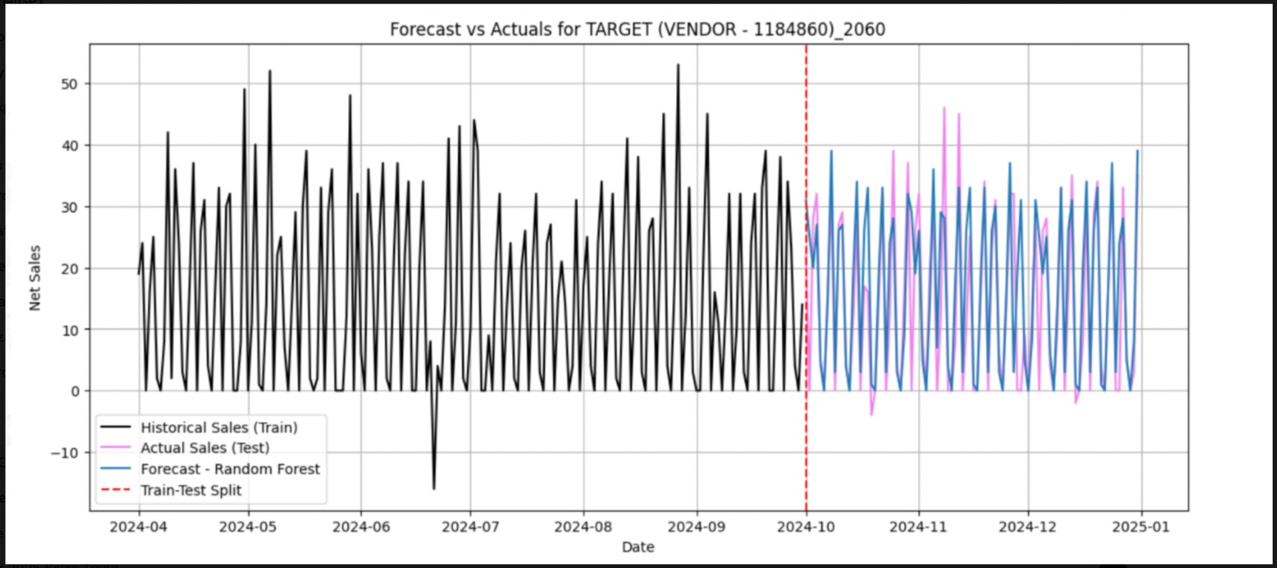

Fig. 11: Sales Forecast for Target

The forecast visualization for *TARGET (VENDOR - 1184860)_2060* illustrates the historical sales trend, test period actuals, and the forecast generated by a *Random Forest* model. The t*raining data (black)* shows a high-frequency oscillating pattern, with sales fluctuating significantly on a daily or weekly basis. There are a few noticeable dips, particularly around June 2024, which could indicate external disruptions such as stockouts or promotional periods. The t*est period (purple for actuals, blue for forecast)* follows a similar pattern but appears to be more erratic, with peaks and valleys that the model attempts to capture. The *Random Forest forecast (blue)* does a relatively good job of tracking the general fluctuations of the actual sales, but there are moments where it overestimates or underestimates. The *train-test split (red dashed line)* in early *October 2024* marks the transition to forecasting. Given the high variability in sales, additional features such as holiday effects, price changes, or competitor activity may improve the model's predictive power. Further tuning of hyperparameters or incorporating additional temporal features may also enhance accuracy.Fine-tuning the model and incorporating external influences can further enhance forecasting accuracy, helping optimize inventory management and sales strategies.

1. **Retailer: King Soopers**

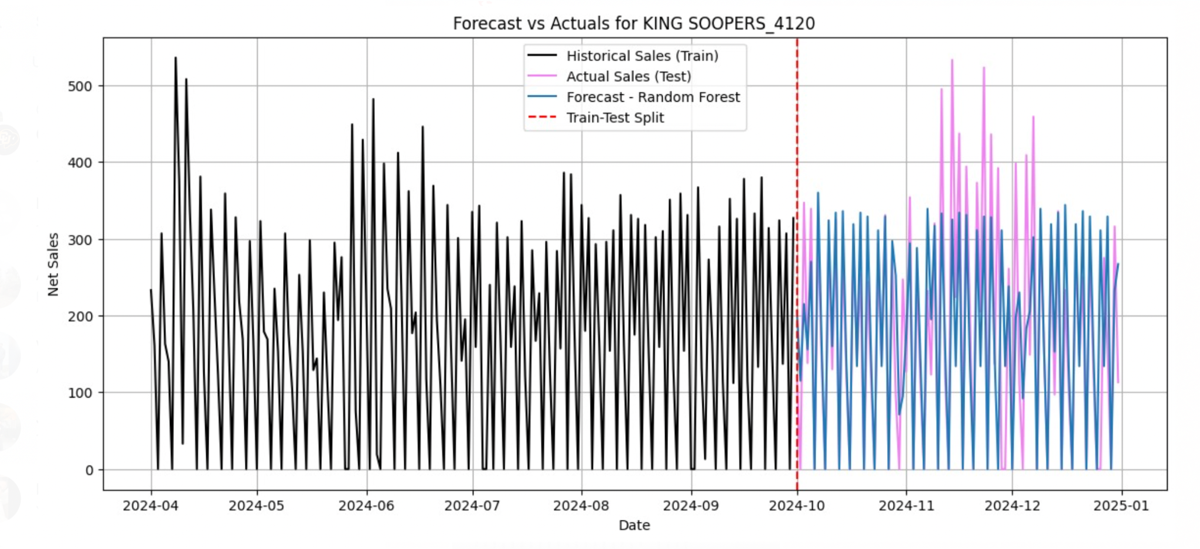

Fig. 12: Sales Forecast for King Soopers

The forecast visualization for *KING SOOPERS_4120* presents a detailed comparison between historical sales (train), actual sales (test), and forecasted values using a *Random Forest model*. The training period (black) exhibits a high degree of sales volatility, with frequent fluctuations and periodic spikes, suggesting strong seasonality or promotional effects influencing sales. The *test period (blue)* maintains a similar fluctuating pattern but appears to have a broader spread, indicating higher variance in actual sales compared to the historical period. The *Random Forest forecast (purple)* follows the general trend of the test data but shows significant deviations, particularly with over-predictions in some peaks. The *train-test split (red dashed line)* at the start of *October 2024* marks the transition, after which the model attempts to predict future sales. The forecast captures the general sales pattern but struggles with extreme spikes and dips, which may indicate that the model is not fully capturing the underlying drivers of sales variability. Improvements could be made by incorporating external factors such as promotions, holidays, or weather conditions to enhance predictive accuracy.

**3. Time Series Analysis using Prophet**: We implemented the *Prophet Model* to forecast daily net sales for multiple unique store locations identified by the 'key' column. The dataset is processed to ensure each store has at least 100 days of historical data, after which the dataset is split into training and testing sets with a cutoff date of October 1, 2024. It is configured with *yearly & weekly seasonality, daily seasonality disabled, and a changepoint prior scale of 0.05* to prevent overfitting. Performance is evaluated using *MAE* and *R²* scores.

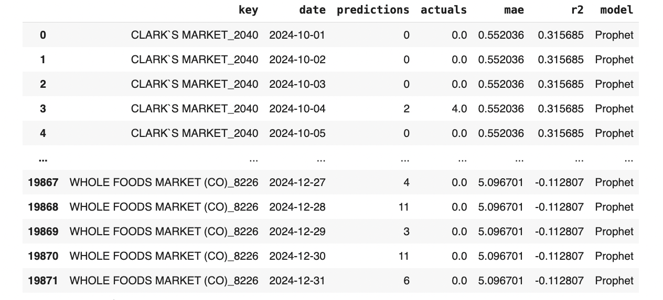

Fig. 13: Prophet Model

* Model Performance Variability: Some stores show low MAE (better predictions), while others have high error and negative R² scores, indicating poor fit due to data trends or external factors.
* Insufficient Data: Stores with <100 historical records were excluded, highlighting dataset gaps.
* Prediction Issues: Some stores have zero forecasts despite actual fluctuations, and cases like Whole Foods Market (CO)_8226 show negative R², meaning predictions are worse than a simple mean.
* Strengths & Limitations: Prophet captures seasonal trends but struggles with irregular demand, requiring external regressors or hyperparameter tuning for improvement.

**4. Exponential Smoothing:** We applied the Exponential Smoothing Model to forecast daily net sales for multiple store locations, ensuring at least 100 days of historical data before splitting into training (pre-Oct 1, 2024) and testing sets.

The model uses:

* Additive trend
* Weekly seasonality (seasonal period = 7 days)

Performance is evaluated using Mean Absolute Error (MAE) and R² Score.

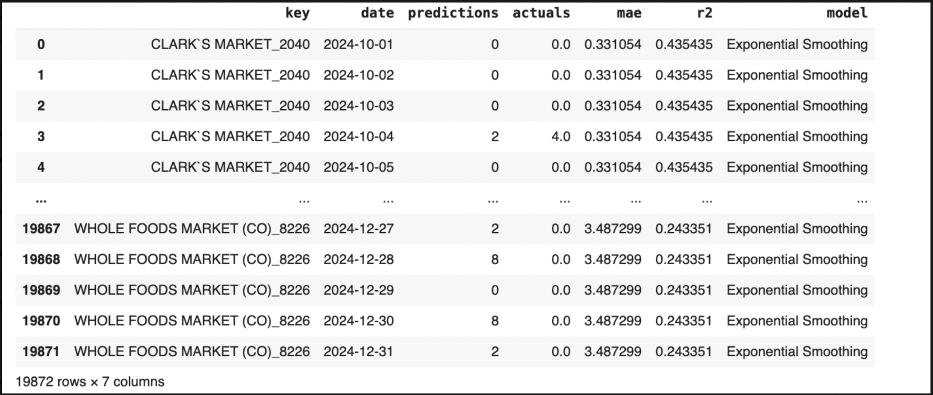

Fig. 14: Exponential Smoothing

The model incorporates an additive trend and weekly seasonality (7-day periods) to capture recurring patterns. Performance varied across stores, with some showing *low MAE* (better accuracy), while others had *low or negative R² scores*, indicating poor predictive power. Stores with fewer than 100 historical records were excluded, highlighting gaps in the dataset. Some predictions remained consistently zero despite actual fluctuations, suggesting limitations in capturing demand patterns. Certain stores, such as *Whole Foods Market (CO)_8226*, exhibited *low R²* scores, meaning predictions were not well-aligned with actual sales. While Exponential Smoothing effectively models seasonality and trends, it struggles with irregular demand patterns, requiring parameter tuning or alternative approaches for improved forecasting.

**5. Decision Tree Classifier**: We applied the *Decision Tree Classifier* with aggressive constraints to prevent overfitting. It is used to categorize sales as high or low based on the median value. The model helps interpret relationships between variables and classify sales performance.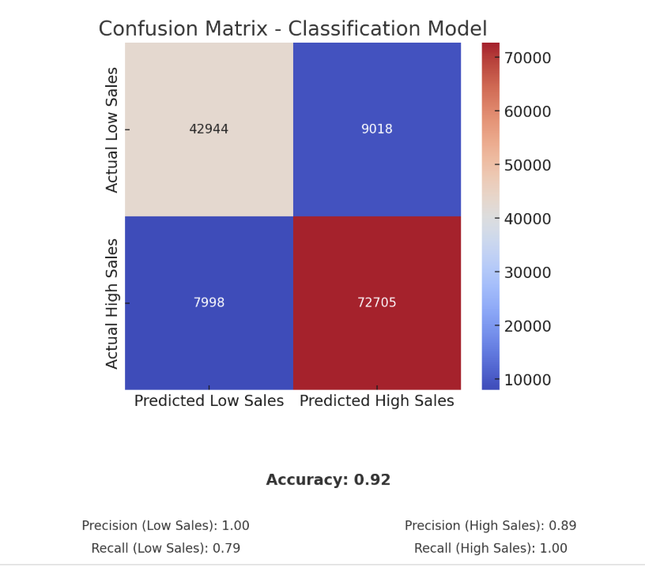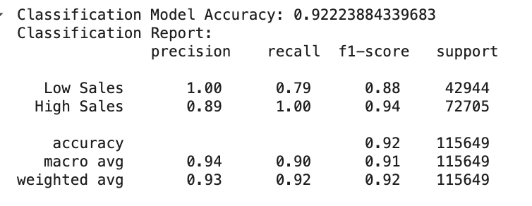

#### 

#### Fig. 15: Confusion Matrix (Decision Tree)

#### 

#### The model demonstrates strong performance in identifying High Sales, achieving a good percentage of recall, ensuring no actual High Sales are misclassified. Additionally, it maintains a low false positive rate for Low Sales, meaning predictions for Low Sales are highly reliable. However, the model tends to favor predicting High Sales, leading to 21% of actual Low Sales being misclassified. To improve balance, enhancing recall for Low Sales through classification threshold adjustments, decision boundary optimization, or incorporating additional features could help reduce false negatives and improve overall model accuracy.

**6.** **Extra Trees Model to improve the accuracy:** Extra Trees Model outperformed Decision Tree by providing higher accuracy and better handling of class imbalances. The confusion matrix indicated Extra trees had fewer misclassifications compared to Decision Tree. This model's gradient boosting mechanism allows it to learn complex patterns more effectively, making it the preferred choice for sales forecasting and anomaly detection.

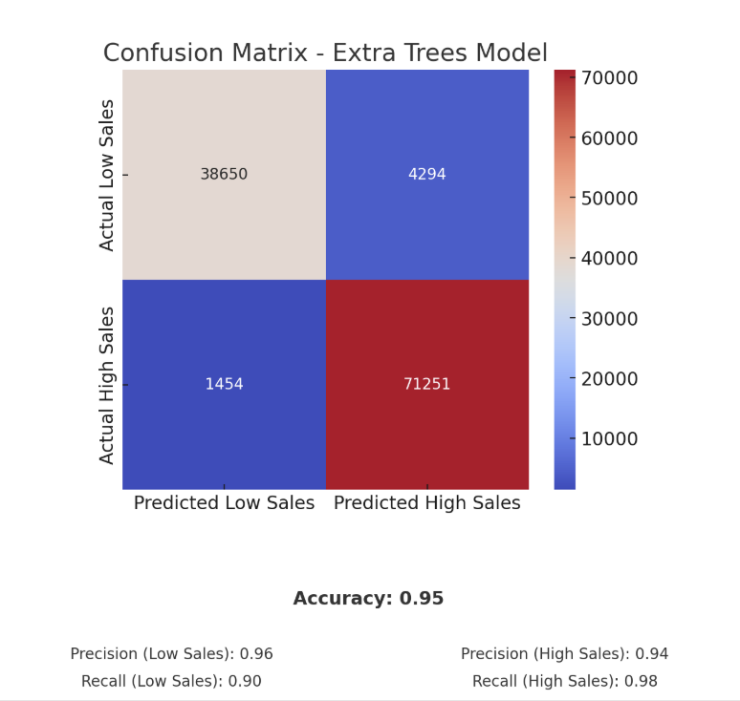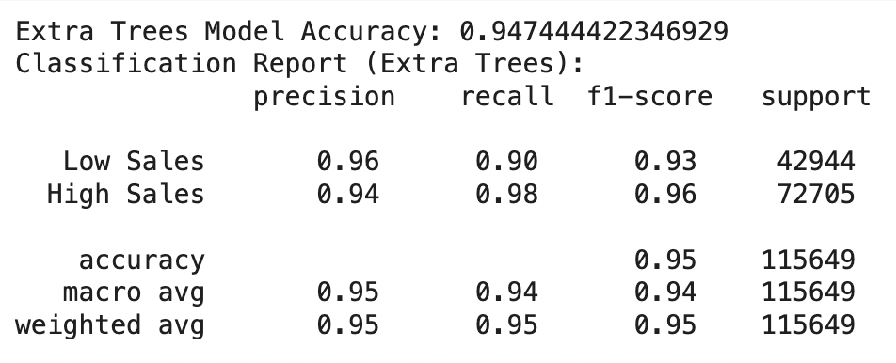

Fig. 16: Confusion Matrix (Extra Trees Model)

**7. Clustering on net sales by Zip codes:** In retail analytics, understanding store performance at a granular level is crucial for optimizing operations, inventory management, and strategic decision-making. One effective way to achieve this is through *clustering analysis*, which groups stores based on similarities in their sales performance and location attributes.We performed cluster analysis that examines store performance using *Net Sales and Store ZIP codes* to understand which locations are thriving and which needs attention to optimize inventory, improve sales, and cut losses.

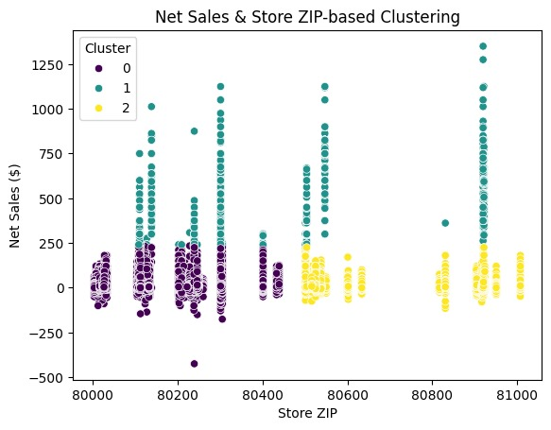

Fig. 17: Clustering on Net Sales by zip code

* The clustering analysis segments stores into three groups based on net sales and ZIP codes, helping identify high, average, and low-performing locations. High-sales clusters indicate strong demand, necessitating adequate stock levels, while low-sales clusters suggest overstocking issues, requiring better inventory management and targeted promotions.
* Certain ZIP codes show consistently high or low sales, highlighting areas for potential expansion or necessary operational improvements. Variability within regions suggests that store-specific factors like visibility, customer preferences, or competition may influence sales.
* This analysis supports strategic decision-making by identifying growth opportunities, optimizing resource allocation, and improving sales performance in struggling locations through pricing adjustments, targeted marketing, or product optimization.

**Adapting this information to an Interactive Dashboard**

Our team chose Tableau as the culmination of our workable solutions to get all members of Rudi’s involved in the data. The insights that can be pulled from summary statistics and the predictive models are valuable for drivers and executives alike. We are working on integrating our machine learning models previously mentioned into the Tableau during our next iteration. Although we are using an extract of the data to show its potential as a valuable solution, Tableau can pull from an active dataset and update the figures as they are entered. The value in this is that all people within the network can access real time figures in a quick to interpret manner. We currently have eight data worksheets that are amalgamated into 4 dashboards.

1. **Retailer Summary Statistics**

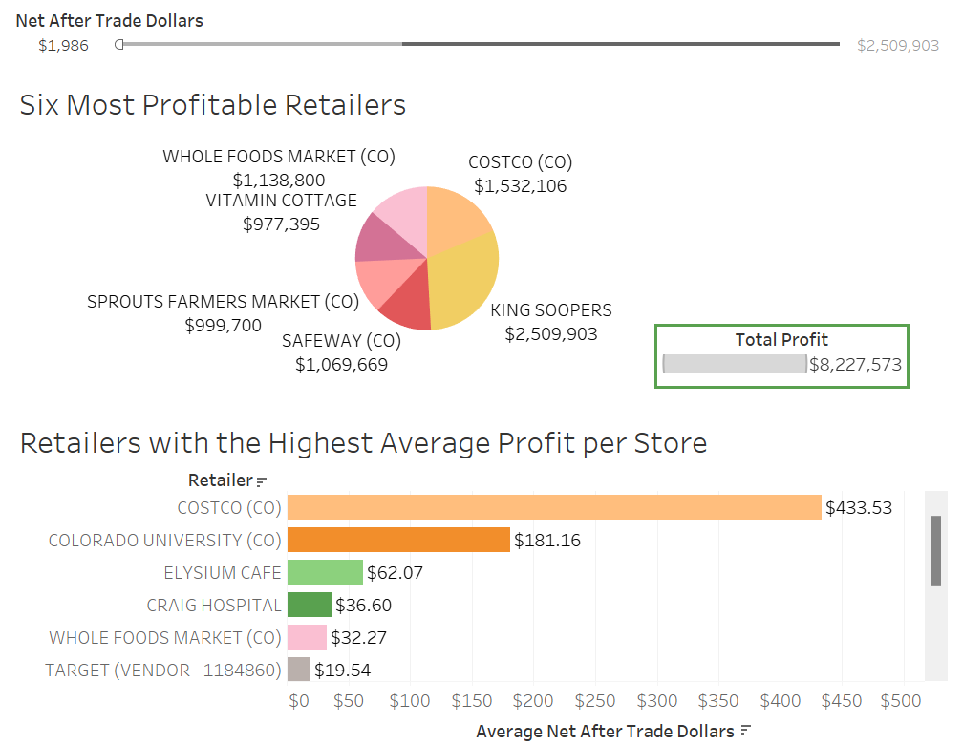

Fig. 18: Retailer Dashboard

This dashboard’s Net After Trade Dollars slider at the top adjusts both the Six Most Profitable Retailers pie chart, the Retailers with the Highest Average Profit per Store, and can be used to display how much profit the selected range of retailers make.

Each of the six highest profiting retailers can be highlighted and their profit per store will be isolated in the table below. When you hover over the charts the tooltip displays Total Net After Trade Dollars, Average Net After Trade Dollars, and the number of stores.

1. **Store Summary Statistics**

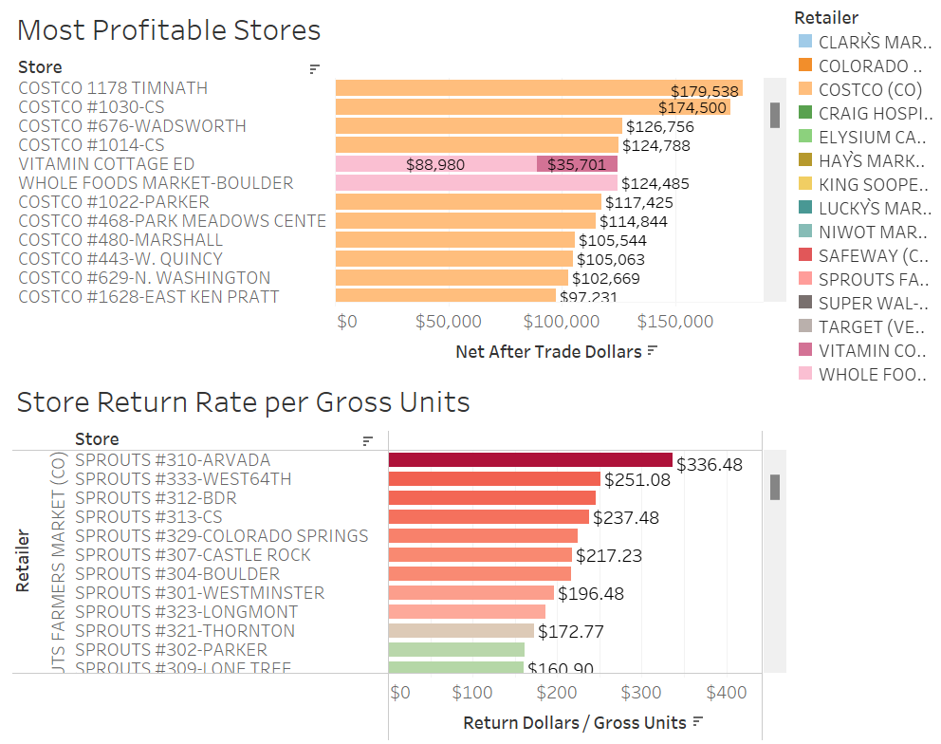

Fig. 19: Store Dashboard

Stores in the Store Return Rate per Gross Units bar graph can be highlighted to be isolated on the Most Profitable Stores chart. The key on the right highlights the retailer on the store profitability chart. The tooltip displays Retailer, Store, and either Total Net After Trade Dollars or Return Dollars per Gross Units.

1. **Products Summary Statistics**

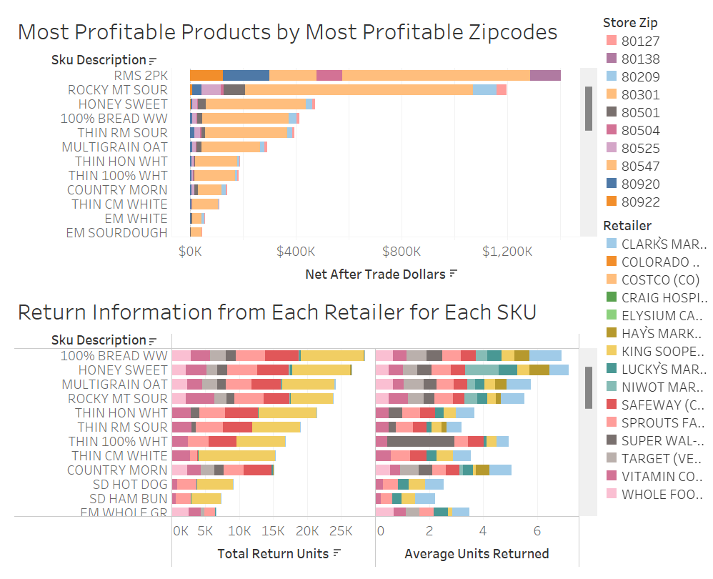

Fig. 20: Product Dashboard

The Most Profitable Products by Most Profitable Zip codes can be isolated by zip code where the tooltip contains SKU description, zip code, city and Total Net After Trade Dollars.

For Return Information from Each Retailer for Each SKU, the key on the right highlights SKU for the selected retailer. The tooltip includes retailer, SKU, and return information.

1. **Route Summary Statistics**

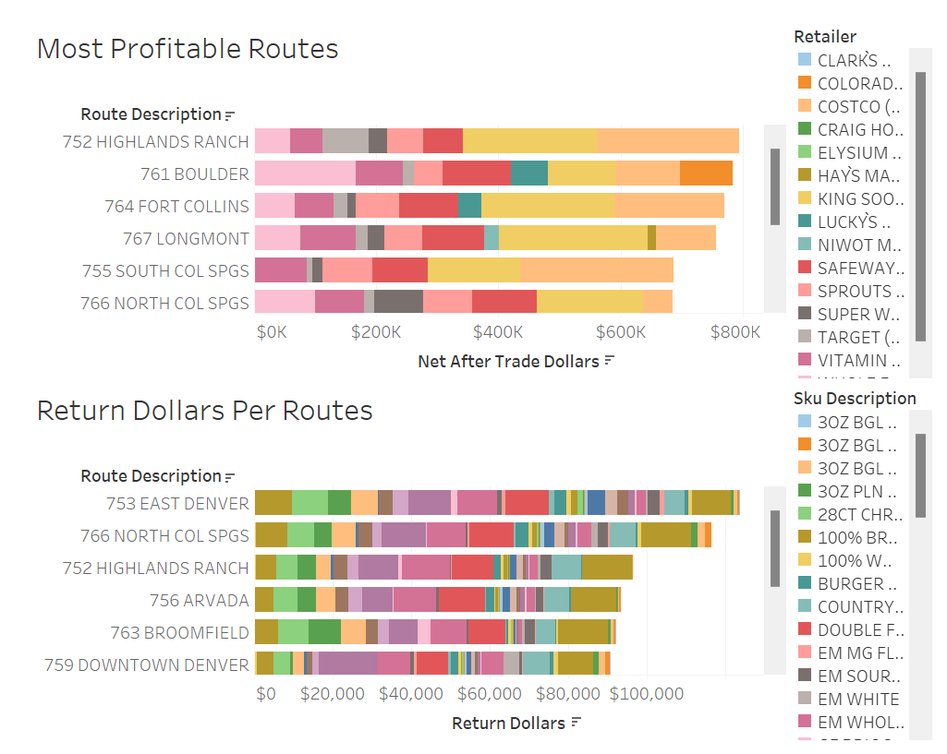

Fig. 21: Route Dashboard

The upper table, Most Profitable Routes, displays Total Net After Trade Dollars for each route, where you can highlight the retailer with the key on the right. The tooltip includes the retailer, route, and Total Net After Trade Dollars.

The Return Dollars Per Routes chart graphs route (with description) on the Y-axis and Return Dollars on the X-axis. The tooltip includes the route, SKU, and the Return Dollars.

**Generative AI Appendix**

1. How do I implement and compare various forecasting techniques on machine learning-based approaches?
2. What can we do and why clustering is important in the bakery industry?
3. Why should we focus on the return rate by retailer, store city, and product?
4. About store performances, is it important to showcase the most profitable stores?
5. What are the key business impacts and strategies based on the models I ran?
6. Can you help me understand the main strategies to understand the bakery business?
7. Help me understand the XGBoost ML algorithm to understand the performance.
8. What are the key strategies adopted by various food industries to lower the return rate?
9. What is the difference between return and exchange of products from the retail stores?
10. What are the top reasons customers/retailers return products excluding expiration of products?
11. How do external factors (location, seasonality, competition) influence store performance?
12. What are the key business insights derived from forecasting models in the bakery industry?
13. How can return rate analysis influence supply chain optimization and product quality?
14. How does packaging innovation impact return rates in the food industry?